SOFTWARE ENGINEERING – CSA1020

Name: Deepalakshmi S
Register Number:192511379

EXP- 4
SCRUM PROJECT IN JIRA
Aim
To create and manage a Scrum project in Jira.
Procedure
1. Create Scrum project.
2. Add 5 backlog items.
3. Prioritize backlog.
4. Create 1- week sprint.
5. Move tasks to sprint.
6. Start sprint.
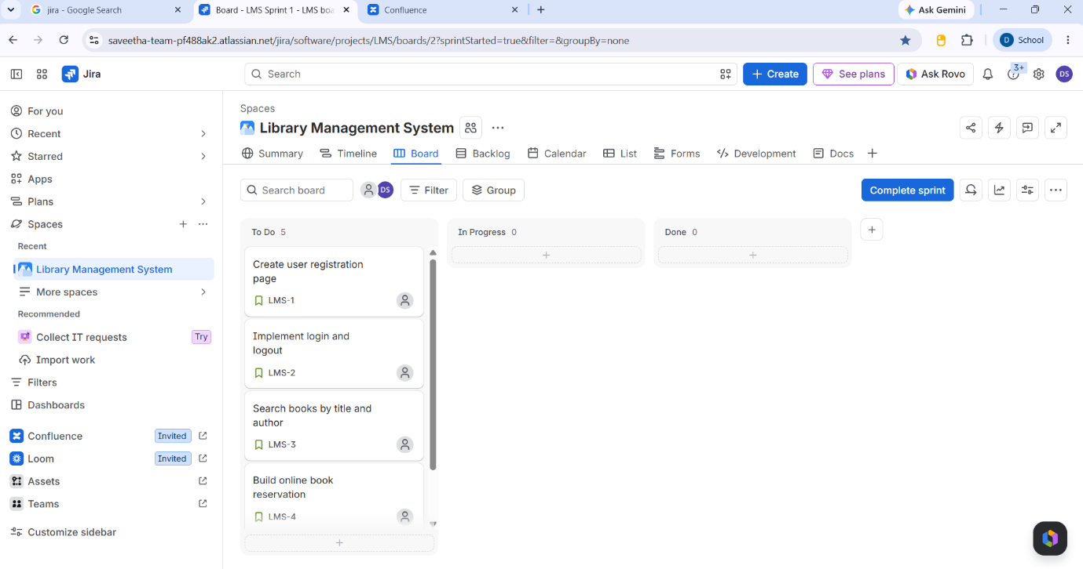
7. Update task status until completion.
